Fire Fighting Robot

Supervisor:-
Dr. Jayanthi Sivaswamy
Dr. Bipin Indurkhia

Submitted by:-
Rishi Gupta-200430020
Sandeep Saini-200431007

Index

S.No. | Content | Pg.No.
1 | Aim of the project | 3
2 | Desired Specifications | 3
3 | Apparatus | 4
4 | Block Diagram | 5
5 | Circuit Diagram | 6
7 | Working of Robot | 7-8
8 | Comparator | 9
9 | Darlington pair | 9
10 | Source Follower | 10
11 | Not using transistors | 10
12 | Mono stable 555 | 11
13 | Difficulties faced and solutions | 12-13
14 | Applications | 14
15 | Limitations and future extension | 14
16 | What We Learnt | 15
17 | Bibliography | 16

Aim of the Project

The aim of the project is to make a robot which can follow a black strip on a white floor and can extinguish the fire on the path. The robot can be used in the rescue operation. Thus the robot can act as a path guider in normal case and as a fire extinguisher in emergency.

Design Specifications
- For proper functioning of the robot needs a voltage supply of about 5.3V and current about 0.7A.
- The robot should be able to distinguish between the white and the black surface.
- If the black surface suddenly ends, the robot should keep on moving in the direction it last moved until the black line is again there.
- It should stop and extinguish fire and restart only after making sure that the fire has been extinguished.
- This could not be run using the dry cells because of the current requirement.

Material Required

The component list for making the robot is as follows:-

S.No | Material Required | Description | Quantity
1 | LM358 | Dual Op-Amp | 3
2 | NE555 | Timer | 1
3 | SL100 | NPN transistor | 8
4 | SK100 | PNP transistor | 1
5 | 7408 | AND IC | 1
6 | 7432 | OR IC | 1
7 | Vector Board |  | 1
8 | DC motors |  | 3
9 | LDR | (Light dependent resistance) | 3
10 | IR Receiver | (for heat) | 1
11 | 32C | Power NPN transistor | 2

Block Diagram

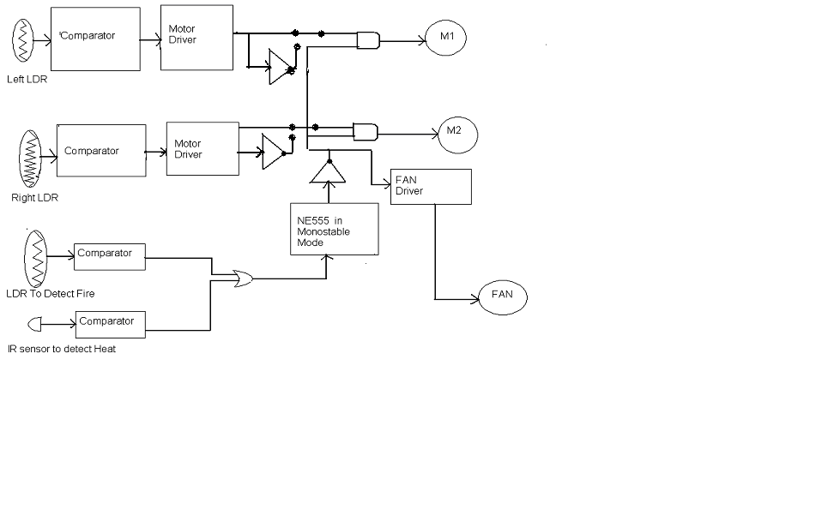

Circuit Diagram
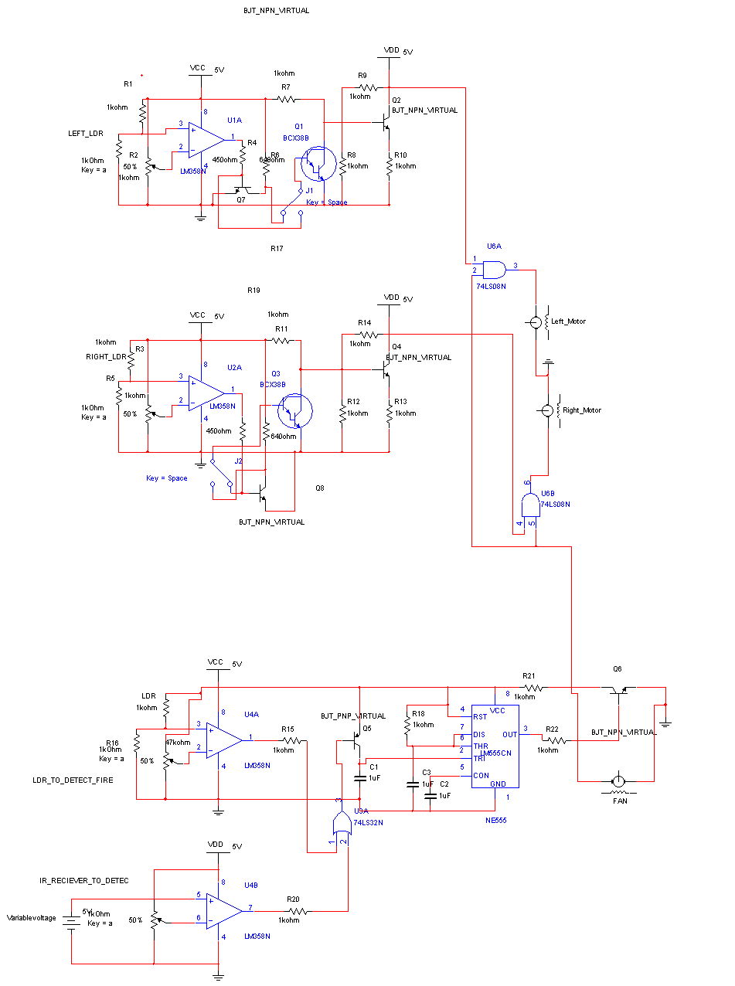

Working of the Robot

The circuit implemented consists mainly of two different sub-circuits.
The first part comprises of making the robot follow a black strip. This was done using a comparator circuit using the LDR whose reference voltage was fixed using the potentiometer. This was based on the phenomenon that the resistance of the LDR decreases as the intensity of light falling on it increases. In our case, the light reflected from the white surface is more than that from the black surface. Therefore, the voltage in positive terminal of the comparator remains high as long as the robot is moving on white surface. If the black surface come under one of the two LDR’s the motor corresponding to that LDR stops, the other making it move away from the black line. But as the other LDR crosses the black line, its motor stops, the other forcing it in other direction, resulting in its following the black line. Thus ,the output voltage of the Op-Amp has been varied according to the need,but the current flowing through the output of Op-Amp is in some mA .Thus there was need for current amplification. The Darlington –pair was used for the same. The resistance of the motor was 5-10ohms,thus source follower circuit was used.
The second part comprised of using LDR’s and IR-receivers to detect flame .The dual Op-Amp LM358 was used for the same. The two comparator circuits were used .For LDR, the working was same, but for IR receiver the voltage and not the resistance vary according to the intensity of light. Thus the two ends of IR-receiver were connected to ground and positive terminal of the comparator .The output of these two were ORed and given to a monostable 555 timer with time period of 4 sec.555 was used because when the robot sees the fire ,the fan starts and the motors stop but when fan starts the intensity of light decreases and hence the two motors start again and there is a chance that the motor starts before the fire is extinguished .The 555 helps in generating a high pulse of about 4 seconds which will remain high and will not depend on the intensity of light for the same duration .Thus , this will make sure that the fire is extinguished before moving ahead. Once the fire is extinguished it will retain its original motion.

The individual working of each of the sub-circuits is given below:-
- Comparator Circuit:-

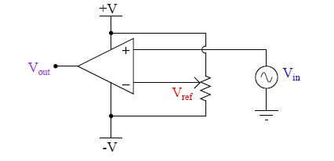

Vout is high for Vin greater than Vref and is low for Vin less than V ref.
- Darlington Pair:-

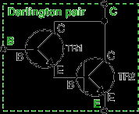

A darlington pair behaves as a single transistor with current gain equal to product of current gain of two transistors
3. Source Follower:-

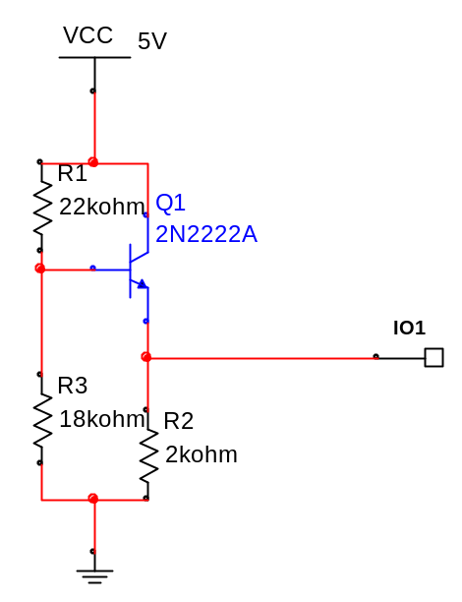

The source follower is used to avoid voltage drop due to low output impedance. It supplies the same amount of voltage and current but can drive low resistance devices.
- Mono-stable NE555:-
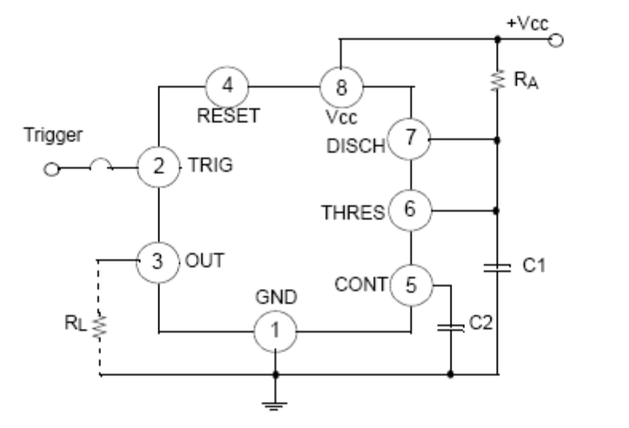
Here the popular 555 timing IC, is wired as a mono stable. The timing period is precise and equivalent to:-
W=1.1 x R₁ x C₁
With component values shown this works out at approximately 1.1msec.The output duration is independent of the input trigger pulse, and the output from the 555 is buffered and can directly interface to CMOS or TTL IC's, providing that the supply voltages match that of the logic family.

4. Not using NPN transistor:-

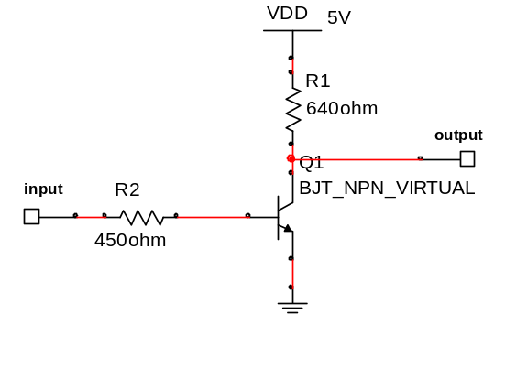

Difficulties faced and steps taken

- First we used 741 for the comparator circuit but the output of the comparator was around 4.5V when high and 1.8 V when low. The AND IC used considered this as a logic high and hence the circuit did not work according to the logic.LM-358 was used to overcome the difficulty. Its logic high is 3.8V and logic low is 0V.
- The output of the comparator gives very less output current which can not drive the motor. Thus, the Darlington pair was used to increase the current.
- The current gain of different SL100 transistors used varied from 100 to 750 .Thus number of transistors used in the Darlington circuit were 3 on one side and four on the other.
- The output impedance of the motor is few ohms. Thus to run the motor one required a source follower circuit.
- Though the line follower began to work, the current flowing through SL100 of the source follower circuit exceeded the maximum limit. Thus, SL100 had to be replaced by 32C.
- The fire extinguishing part of the robot also faced the problem. The robot used the fan to extinguish the fire. The intensity of light and heat governed the speed of the fan. But as the fan tried to extinguish the fire, the intensity of light decreased and hence the robot started to move without extinguishing the fire. The mono-stable 555 was used to solve this problem .It made the fan to rotate for a fixed duration without depending on intensity of light for a fixed duration after which it continued on its path.
- The main problem which could not be overcome was that it could not be driven by batteries. The power requirement of the circuit could not be received using the batteries.
- Selecting the best chassis was a time consuming process.

Applications:-
- The robot can be used as a guider to guide the visitors from the entrance to the main office .
- It can help doctors to carry the medicines from one ward to another .
- The main purpose is to rescue the people by extinguishing fire in a building .

Limitations and future Extensions:-
In the present condition it can extinguish fire only in the way and not in all the rooms. It can be extended to a real fire extinguisher by replacing the fan by a carbon-di-oxide carrier and by making it to extinguish fires of all the room using microprogramming.
Also the robot could not be run through the batteries because at some conditions the current requirement for the circuit rises to about .8A which is very high and can not be obtained using batteries.

What We Learnt

- The first working robot was in itself a great pleasure and satisfaction.
- We learnt the implementation of the big circuit using the basic small circuits.
- The step wise execution of the circuit helps to reach the goal quickly and more accurately.
- The team work is the most important thing we learnt.
- Never lose hope.
- There is a huge difference between the theoretical and the practical world
- We learnt to work under the supervision and guidelines of our professors.

Bibliography

These are some of the sites we visited:-
http://www.hobbyengineering.com/rmapIndex.html
http://www.ridgesoft.com/buildingbots.htm
http://www.seattlerobotics.org/guide/infrared.html
http://www.robotroom.com/RBFB.html //line following robot
http://www.mstracey.btinternet.co.uk/interest.htm
http://www.dudi30.republika.pl/galeria/index.html //New robot every week
http://www.robotics.com/robomenu/index.html

